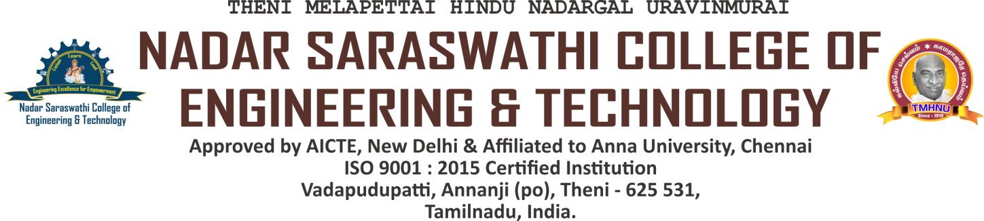

EVIDENCES FOR STACK HOLDERS FEEDBACK ACTION

Sl. No. | Name of the Events | Date
1 | Guest Lecture on Grab the Core Competency | 01/04/2022
2 | Seminar on Higher Education Opportunities available in India and Abroad | 08/10/2022
3 | Workshop on Literacy Fiesta – Beyond the Books | 12/10/2022
4 | Inauguration of Bureau of Indian Standards (BIS) Club | 28/11/2022
5 | Bureau of Indin Standards (BIS) Club  Industrial Exposure Visit | 30/11/2022
6 | Workshop on Primavera Software and its Career Opportunities in Abroad | 21/04/2023
7 | Gueat Lecture on Communication Skills – A Practical Approach | 10/06/2023
8 | National Level Technical Symposium | 21/07/2023
9 | Interactive Lecture on LV Switchgear, Ev Chargers and Industrial Automation | 03/11/2023
10 | Inauguration of Student Career Connect Cell | 16/11/2023
11 | Smart India Hackathon 2023 Winners | 19/12/2023 and 20/12/2023
12 | Internship cum Project at L.G. Balakrishnan and Bros Pvt. Ltd., Coimbatore (Final year Mechanical Engineering (4 Students) | 20/12/2023 to 20/01/2024
13 | Students Field Visit – Transformer Installation by TANGEDCO | 04/08/2023
14 | Placement Training Schedule – All years | August 2023 to November 2023
15 | Placement Training Schedule – Coding & Decoding – Final Year | 27/10/2023, 28/10/2023 & 30/10/2023
16 | First Year Industry Visit – SUN Observatory Lab, Kodaikanal | 07/12/2023 & 08/12/2023
17 | Dr.Kalam Young Achievers Awards 2023 | 22/09/2023
18 | Faculty Development Programmes Certificates 2023 | ---
19 | NPTEL Courses Certificates 2023 | ---

EVIDENCES FOR STUDENTS FEEDBACK ACTION

FACULTY DEVELOPMENT PROGRAMMES CERTIFICATES 2023

EVIDENCES FOR STUDENTS FEEDBACK ACTION

NPTEL COURSES CERTIFICATES 2023

